**Creative Computing with **

**Coding Your Story with Terminal Quest**

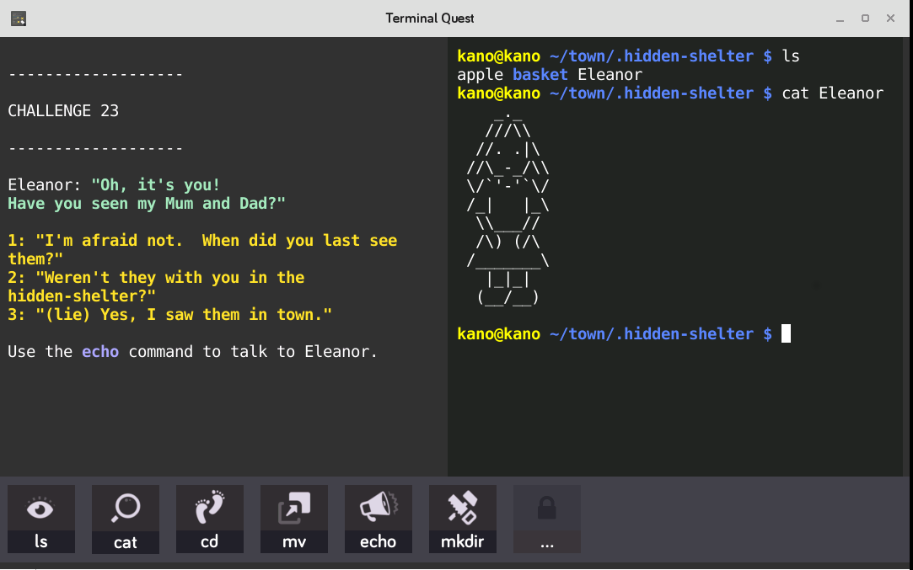

Use Terminal Quest to help learners identify setting, characters, plot, and predictions.

|  |  |  |
| --- | --- | --- |
| **Title: Terminal Quest**  **Time: 1 hour 15 minutes**  **Level: Beginner** | | |
| Learning Objectives:   * Learners will be able to give examples of characters, setting, and plot in a story. * Learners will follow the story in Terminal Quest and make predictions on what they think will happen. * Learners will understand what a terminal is and how code they write comes alive as part of a story | | |
| Pupils should be able to:   * Understand both the books they can already read accurately and fluently and those they listen to by:predicting what might happen on the basis of what has been read so far * Understand what they read by asking questions to improve their understanding | | **Standards:**  **UK National Curriculum** |
| CCSS.ELA-LITERACY.RL.4.3  Describe in depth a character, setting, or event in a story or drama, drawing on specific details in the text (e.g., a character's thoughts, words, or actions).  [CCSS.ELA-LITERACY.RL.5.1](http://www.corestandards.org/ELA-Literacy/RL/5/1/)  Quote accurately from a text when explaining what the text says explicitly and when drawing inferences from the text.  [CCSS.ELA-LITERACY.RL.7.1](http://www.corestandards.org/ELA-Literacy/RL/7/1/)  Cite several pieces of textual evidence to support analysis of what the text says explicitly as well as inferences drawn from the text.  [CCSS.ELA-LITERACY.RL.8.1](http://www.corestandards.org/ELA-Literacy/RL/8/1/)  Cite the textual evidence that most strongly supports an analysis of what the text says explicitly as well as inferences drawn from the text. | | **Standards:**  **ELA Common Core** |
| **Starter: 15 min**  [Read a short story](http://storyberries.com/category/15-min-stories/) to the class. After reading, have learners identify the setting, characters, and summary of the plot.  If you could change one thing about the story, what would it be? Remind that coding gives students powers to create and change rules!  **Content refresher:**  If students need a refresher, go over setting, characters, plot, and predictions. | | |
| **Collect Kanos:** 5 min  **Retrieve Computers, Turn On, Log In..** | | |
| **Exploration Activities: 35 min**  **Challenge 1:** Open up LeapPad and type the following words. “Characters”, “Setting”, “Plot.”  Also open up the Terminal Quest app.  Today, students will learn about terminal and go on an adventure. Have students follow the story, and see if you can identify the characters, setting and plot of the story.  **Challenge 2:** Before we leave for the day, let's type another word in LeafPad. Type “Prediction.” Next to the word, write what you predict will happen next in Terminal Quest and why. | | |
| **Sharing: 15 min**  Select a few students to share their predictions. What will happen next in your Terminal Quest adventure? | | |
| **Kano Cleanup:** 5 min  **Power down and put away the Kanos** | | |